A
Project-Based Learning
Developing a Multi-Field Input Form in Flutter
Submitted
In Partial Fulfilment of the Requirements for the Award of a Degree.
BACHELOR OF TECHNOLOGY

IN

COMPUTER SCIENCE AND ENGINEERING
(DATA SCIENCE)

Submitted By
CH.AKSHITHA ( 237Z1A6729)
Under the Guidance of
Mr.Vinaysagar
Assistant Professor

SCHOOL OF ENGINEERING
Department of Computer Science and Engineering
(DATA SCIENCE)

NALLA NARASIMHA REDDYEDUCATION SOCIETY’S GROUP OF INSTITUTIONS
(AN AUTONOMOUS INSTITUTION)

Approved by AICTE, New Delhi, Chowdariguda (V) Korremula ‘x’Roads, Via Narapally, Ghatkesar (Mandal)Medchal (Dist), Telangana-500088 2024-2025.



SCHOOL OF ENGINEERING
DEPARTMENT OF COMPUTER SCIENCE AND ENGINEERING
(DATA SCIENCE)

CERTIFICATE

This is to certify that the project report titled “Developing a Multi-Field Input Form in Flutter” is being submitted by Ch.Akshitha (237Z1A6729), in Partial fulfilment of the requirements for the award of Bachelor of Technology in Computer Science & Engineering (DATA SCIENCE) is a record bonafide work carried out by them. The results embodied in this report have not been submitted to any other University for the award of any degree.

Internal Guide | Head of the Department
(Mr.Vinaysagar) | (Mrs.Indrani Vasireddy)

Submission Date:

DECLARATION

I Ch.Akshitha student of Bachelor of Technology in Computer Science and Engineering(Data Science), Nalla Narasimha Reddy Education Society’s Group Of Institutions, Hyderabad, Telangana, hereby declare that the work presented in this project work entitled Developing a Multi-Field Input Form in Flutter is the outcome of my bonafide work and is correct to the best of my knowledge. This work has been undertaken while taking care of engineering ethics. It contains no material previously published or written by another person, nor material which has been accepted for the award of any other degree or diploma of the university or other institute of higher learning.

CH.AKSHITHA (237Z1A6729)

Date:

Signature:

ACKNOWLEDGEMENT

I want to express our profound gratitude to our real-time research project coordinator, Mr.Vinaysagar, Assistant Professor, Department of Data Science, NNRG, for her support and guidance in completing my project and for giving me this opportunity to present the research project work.
I profoundly express thanks to Mrs Indrani Vasireddy, Associate Professor & Head, Department of Data Science, NNRG, for her cooperation and encouragement in completing the project successfully.
I wish to express our sincere thanks to Dr G.Janardhana Raju, Dean School of Engineering, NNRG, for providing the facilities for the completion of the project.
I wish to express our sincere thanks to Dr C.V.Krishna Reddy, Director, NNRG, for providing the facilities for the completion of the project.Finally, I would like to thank the Project Co-Ordinator, all the faculty members and supporting staff, Department of Data Science, NNRG, for extending their help in all circumstances.

By :
CH.AKSHITHA( 237Z1A6729 )

CONTENTS Page No.
ABSTRACT 1
- INTRODUCTION 2
1.1Problem Definition 2
1.2Objective of the project 2
1.3 Limitations of the project 2
2.SYSTEM ANALYSIS 3
2.1Existing System 3
2.2Proposed System 3 2.3Software Requirements 4 2.4Hardware Requirements 5
3.IMPLEMENTATION 5-6
3.1Methods of Implementation
3.2Algorithmic Approach
3.3Explanation of Key Functions
4.GITHUB 6-7
4.1Registration How to put a project into GitHub 5.SOURCE CODE 8-9
6.OUTPUT SCREENSHOTS 10
7.CONCLUSION AND FUTURE ENHANCEMENT 11-13
7.1Project Conclusion
7.2Future Enhancement

8.REFERENCES 12-13
8.1Paper References
8.2Web References

ABSTRACT

Flutter is a powerful UI framework used for building cross-platform applications.
This project demonstrates how to create a Student Registration Form using multiple input fields such as:
- Text Fields (Name, Roll Number)
- Dropdown Button (Department Selection)
- Checkbox (Hosteller Status)
The project includes field validation, data submission, and success notification. It helps students understand the basics of Flutter UI design, form validation, state management, and widget interaction.
This simulation is fully offline and focuses on learning core Flutter concepts.

1. INTRODUCTION
1.1 Problem Definition
Students frequently need to fill out registration forms for various academic and administrative purposes. Traditional manual forms and basic digital forms often lead to issues such as incomplete entries, invalid data, and poor user experience due to lack of proper validation and a clean interface.
To overcome these challenges, there is a need for a modern digital form solution that ensures accuracy, consistency, and ease of use across devices. A Flutter-based solution provides the flexibility to design a responsive, structured, and interactive registration form that enhances the overall data-collection process.

1.2 Objective of Project
- To design a multi-field registration form using Flutter.
- To apply validation for user inputs.
- To store and display entered details.
- To demonstrate use of essential Flutter widgets
- To help beginners understand UI interaction & state management
1.3 Limitations of the Project

No database connectivity

Only console output after submission

No backend/server connectivity

2. SYSTEM ANALYSIS

2.1 Existing System
The traditional registration process mainly relies on paper-based forms or basic digital forms. These methods often lead to incomplete entries, manual errors, and time-consuming verification.
Additionally, Flutter’s widget-based architecture allows for easy customization of the form’s layout, colours, and components, making it adaptable for various types of registration processes.
There is no real-time validation, so mistakes are identified only after submission .Storing and retrieving records becomes difficult as the number of students increases. Overall, the system lacks responsiveness, user-friendliness, and efficiency.

2.1.1 Disadvantages of the Existing System
- Manual Errors
- Time-Consuming Process
- No Real-Time Validation
- Poor Accessibility
- Storage & Retrieval Issues
- Lack of Responsiveness

2.2 Proposed System
The proposed system introduces a Flutter-based digital registration form designed to simplify and improve the student data entry process. Flutter enables the creation of a clean, responsive, and visually appealing UI that works seamlessly on both Android and iOS devices. The form includes multiple input fields with built-in validation to ensure that users provide complete and correct information before submission.
Key Features of the Proposed System
- Real-time error messages guide the user to correct mistakes instantly.
- Reducing errors and enhancing the overall accuracy of data collected.
- Additionally, Flutter’s widget-based architecture allows for easy customization of the form’s layout, colours, and components, making it adaptable for various types of registration processes.

Advantages of the Proposed System
- Cross-platform support: Works on both Android and iOS using a single codebase.
- Fast UI rendering: Flutter’s rendering engine ensures smooth animations and quick loading.
- Beginner-friendly development: Simple widget structure makes it easy for learners to understand and build.
- Real-time validation: Immediate feedback helps eliminate incorrect or incomplete inputs.
- Improved user experience: Clean and modern UI increases efficiency and ease of use.

2.3 Software Requirements
Component | Description
Operating System | Windows / Linux
Framework | Flutter SDK
Compiler | GCC
IDE/Editor
  Android Studio / VS Code
Libraries Used | stdio.h, stdlib.h, string.h, time.h

2.4 Hardware Requirements
Component | Description
Processor | Minimum Intel Dual-Core
RAM | Minimum 2 GB
Storage | 500 MB free space
Display | Standard monitor

3. IMPLEMENTATION

3.1 Methods Used:

TextField widgets for input

DropdownButton for department selection

Checkbox for hosteller status

Form validation using GlobalKey

3.2 Algorithmic Approach
1. Start the application.
2. Display the student form.
3. Enter name and roll number.
4. Select department from dropdown.
5. Select hosteller status using checkbox.
6. Validate input fields.
7. If valid, show success message and Print details to console
.
3.3 Key Widgets Used
3.31. TextFormField
The TextFormField widget is used to accept textual input from the user, such as the student’s name and roll number.
It supports built-in validation, making it suitable for forms where data accuracy is important.
In this project, each field checks whether the input is empty and prompts the user with an error message if validation fails.It also uses the onSaved() method to store the final validated values for processing.
3.32.DropdownButton
The DropdownButton widget allows users to select one option from a predefined list—in this case, the department (CSE, ECE, EEE, IT, MECH).
It ensures that the user chooses a valid department instead of typing manually, reducing input errors.The widget is wrapped with setState() to update the UI instantly when a new department is chosen.
3.33.Checkbox
The Checkbox widget is used to determine whether the student is a hosteller or a day scholar.It returns a boolean value and is easy to toggle with user interaction. By placing it inside a Row, the UI looks organized and readable. Using setState(), the UI updates immediately when the checkbox is selected or deselected.
3.34. SnackBar
The SnackBar widget provides instant feedback to the user after they submit the form.
It appears briefly at the bottom of the screen to confirm that the form submission was successful. SnackBars improve user experience by giving quick, non-intrusive notifications without interrupting the workflow.In this project, the SnackBar displays a green-colored success message once all validations are passed.

4. GITHUB
4.1 Registration
- Visit https://github.com.
- Create an account using your email ID.
- Verify your account and log in to your dashboard.
- Set up your profile and install Git on your system if needed.

4.2 How to Put a Project into GitHub
- Open your terminal and navigate to your project folder.
- Initialize git and add your files:
git init git add git commit -m "Initial commit

- Create a new repository on GitHub.
- Link your local repository with the remote one:
- git remote add origin https://github.com/username/NetworkMonitor.git
git push -u origin main

- Your code will now appear on GitHub, accessible publicly or privately.

5.SOURCE CODE

Source Code:

import 'package:flutter/material.dart';

void main() {
runApp(MyApp());
}

class MyApp extends StatelessWidget {
@override
Widget build(BuildContext context) {
return MaterialApp(
debugShowCheckedModeBanner: false,
title: 'Student Registration Form',
theme: ThemeData(primarySwatch: Colors.teal),
home: StudentForm(),
);
}
}

class StudentForm extends StatefulWidget {
@override
_StudentFormState createState() => _StudentFormState();
}

class _StudentFormState extends State<StudentForm> {
final _formKey = GlobalKey<FormState>();
String _studentName = '';
String _rollNumber = '';
String _selectedDepartment = 'CSE';
bool _isHosteller = false;

@override
Widget build(BuildContext context) {
return Scaffold(
appBar: AppBar(title: const Text('Student Registration Form')),
body: Padding(
padding: const EdgeInsets.all(20.0),
child: Form(
key: _formKey,
child: ListView(
children: [
const SizedBox(height: 10),
TextFormField(
decoration: const InputDecoration(
labelText: 'Student Name',
border: OutlineInputBorder(),
),
validator: (value) =>
value!.isEmpty ? 'Please enter student name' : null,
onSaved: (value) => _studentName = value!,
),
const SizedBox(height: 20),
TextFormField(
decoration: const InputDecoration(
labelText: 'Roll Number',
border: OutlineInputBorder(),
),
validator: (value) =>
value!.isEmpty ? 'Please enter roll number' : null,
onSaved: (value) => _rollNumber = value!,
),
const SizedBox(height: 20),
Row(
children: [
const Text(
'Department:',
style: TextStyle(fontSize: 16),
),
const SizedBox(width: 20),
DropdownButton<String>(
value: _selectedDepartment,
items: <String>['CSE', 'ECE', 'EEE', 'IT', 'MECH']
.map<DropdownMenuItem<String>>((String value) {
return DropdownMenuItem<String>(
value: value,
child: Text(value),
);
}).toList(),
onChanged: (value) {
setState(() {
_selectedDepartment = value!;
});
},
),
],
),
const SizedBox(height: 20),
Row(
children: [
Checkbox(
value: _isHosteller,
onChanged: (value) {
setState(() {
_isHosteller = value!;
});
},
),
const Text('Hosteller'),
],
),
const SizedBox(height: 30),
ElevatedButton(
style: ElevatedButton.styleFrom(
padding: const EdgeInsets.symmetric(vertical: 15),
backgroundColor: Colors.teal,
),
onPressed: () {
if (_formKey.currentState!.validate()) {
_formKey.currentState!.save();
ScaffoldMessenger.of(context).showSnackBar(
const SnackBar(
content: Text('Form Submitted Successfully!'),
backgroundColor: Colors.green,
),
);
print('--- STUDENT DETAILS ---');
print('Name: $_studentName');
print('Roll No: $_rollNumber');
print('Department: $_selectedDepartment');
print('Hosteller: $_isHosteller');
}
},
child: const Text(
'SUBMIT',
style: TextStyle(color: Colors.white, fontSize: 18),
),
),
],
),
),
),
);
}

6. OUTPUT SCREENSHOTS

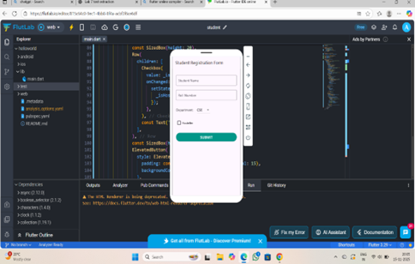

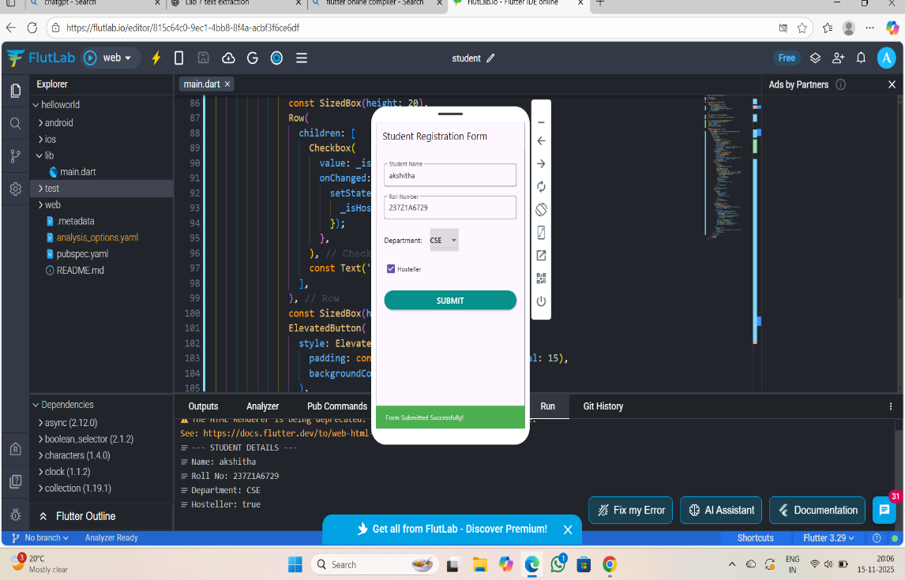

7. CONCLUSION AND FUTURE ENHANCEMENT

7.1 Project Conclusion

This project successfully demonstrates the design and implementation of a multi-field student registration form using Flutter. Students learn UI development, form validation, user interaction, and state management. They also gain hands-on experience with widget structuring, responsive layouts, and clean UI design principles. The project helps learners understand real-time error handling, input validation, and ensuring data accuracy.

7.2 Future Enhancement
- Adding backend storage (Firebase/MySQL)
- Adding profile photo upload
- Exporting data to PDF
- The importance of adopting modern standards like WPA2 and WPA3
- Adding login authentication
- Integrating cloud storage

8. REFERENCES

8.1 Paper References
• Jon R. Lewis, “Human-Computer Interaction: A Practical-Guide for Designers”, 2nd Edition, CRC Press..
• Alan Cooper, Robert Reimann, David Cronin, “About-Face 4: The Essentials of Interaction Design”, 4th Edition, Wiley.
• Nathan Rozentals, “Designing Interfaces: Patterns for Effective Interaction Design”, O’Reilly.
• Donald A. Norman, “The Design of Everyday Things”, Revised Edition, Basic Books..

8.2 Web References
- https://docs.flutter.dev/cookbook/forms/validation – “Build a form with validation” in Flutter official docs.
- https://docs.flutter.dev/ui/widgets – Flutter widget catalog (input widgets, layouts, etc.).
- https://www.geeksforgeeks.org/ – C Programming & Network Security Concepts
- https://www.geeksforgeeks.org/flutter/form-validation-in-flutter/ – Tutorial on form validation in Flutter.
- https://blog.logrocket.com/flutter-form-validation-complete-guide/ – “Flutter form validation: The complete guide”.
- https://docs.flutter.dev/ui/widgets/input – Input widgets overview in Flutter.

